PostgreSQL DB for DWH and ETL Building
PostgreSQL Relational Structures — Task 3: Answer
Author: Mariam Avaliani

1. Theory recap

1.1 Object storage: pages, Free Space Map, Visibility Map, TOAST
Every table and index is stored as one or more files (max ~1GB each) inside the database's directory, split into fixed-size 8KB pages. Each page has a header, an array of item pointers, and the actual tuple data growing from opposite ends toward the middle. A tuple identifier (TID / ctid) is just (page number, item pointer offset). Rows larger than ~2KB are stored out-of-line using TOAST (The Oversized-Attribute Storage Technique). Each table also has two auxiliary files: the Free Space Map (_fsm — tracks how much free space is available on each page, so future inserts/updates can reuse space instead of always appending) and the Visibility Map (_vm — tracks which pages are “all-visible” to every running transaction and which are fully frozen; this is what lets index-only scans skip visiting the heap, and lets VACUUM skip pages it doesn't need to revisit).

1.2 Table variants
- Inherited table — a child table declared with INHERITS(parent) gets its own columns plus all of the parent's columns; queries on the parent automatically include child rows unless ONLY is used. Primary keys, unique constraints, and indexes are never inherited; check/not-null constraints are, unless marked NO INHERIT.
- Partitioned table — declarative CREATE TABLE ... PARTITION BY RANGE/LIST/HASH. Looks similar to inheritance but the parent can hold no rows of its own (all inserts are routed to a matching partition), every partition must share the exact same columns, and a partition belongs to exactly one parent.
- Unlogged table — data is not written to the write-ahead log (WAL), which makes writes roughly 10-15x faster, at the cost of the table being wiped on crash recovery and excluded from replication. Good fit for large staging/import data, session-type data, or anything cheaply reconstructible.
- Clustered table (CLUSTER command) — physically reorders the table's rows on disk to match a chosen index. Speeds up range scans on that index, but locks the table while running, only tracks one index at a time, and the ordering decays again as normal writes happen.

1.3 Index types
- B-tree — the default/standard index. Balanced, multi-branched, keeps data sorted so it supports both equality and range lookups (<, <=, =, >=, >) as well as ordered scans. Good general-purpose choice for highly selective columns and primary keys.
- Hash — stores only the 4-byte hash of the value, so it's compact, but only supports equality lookups (no ranges) and only single-column indexes.
- BRIN (Block Range Index) — instead of indexing individual rows, it stores the min/max summary for each range of physical pages. Extremely small and fast to build, but only effective when the indexed column is naturally correlated with physical row order (e.g. an ever-increasing timestamp); useless if values are scattered randomly through the table.
- GIN (Generalized Inverted Index) — good when a single row maps to many keys (arrays, full-text search, trigrams): it stores a list of keys with a posting list of every row containing that key. Slower to build/update than B-tree, but very fast lookups.
- GiST (Generalized Search Tree) — a general balanced-tree framework where the definition of “what a key means” is pluggable; used for geometric data, full-text search, and (with pg_trgm) trigram similarity search. Faster to update than GIN, but lookups are typically a bit slower.
- SP-GiST — space-partitioned variant of GiST, better suited to some non-balanced data distributions (e.g. points, quad-trees).

1.4 Views vs. Materialized Views
A plain VIEW stores only a query, not data — every SELECT against it re-runs the underlying query, so it always reflects the latest data, but adds no caching benefit. A MATERIALIZED VIEW physically stores the result set on disk like a table, so reads are fast and cheap (especially useful to avoid repeatedly hitting a slow foreign table), but the data becomes stale the moment the underlying data changes — it only updates when explicitly told to via REFRESH MATERIALIZED VIEW, which is a blocking operation unless CONCURRENTLY is used with a unique index in place.

1.5 Foreign Data Wrappers (FDW)
FDWs give PostgreSQL a standardized way to query external data sources (other relational databases, NoSQL stores, or flat files) as if they were ordinary tables. Setting one up always follows the same four steps: install the extension, create a SERVER object describing where the data lives, optionally create a USER MAPPING for authentication, then create the FOREIGN TABLE that maps columns to the remote source. file_fdw (used in Task 5 below) treats a flat file — CSV in this case — as a read-only table; because every query against it re-reads the file from disk, a materialized view is a natural way to cache and speed up repeated access to it.

2. Prerequisite Task
Reconnected to test_db, confirmed the labs schema (created in a previous module) is on the search path, dropped and recreated person, and reloaded it with data:
SHOW search_path;
-- add labs if it isn't already there:
SET search_path TO labs, public;
DROP TABLE IF EXISTS labs.person;
CREATE TABLE labs.person (
id integer NOT NULL,
name varchar(15)
);
INSERT INTO person VALUES(1, 'Bob');
INSERT INTO person VALUES(2, 'Alice');
INSERT INTO person VALUES(3, 'Robert');
What to look for: search_path including labs, DROP TABLE succeeding (or a harmless notice if the table didn't exist yet), and the three INSERTs succeeding without needing to qualify the table name as labs.person.
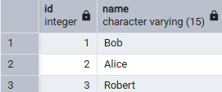
Also briefly read up on EXPLAIN ANALYZE ahead of using it in Task 3/4 below: it actually executes the query (unlike plain EXPLAIN, which only estimates) and reports real elapsed time and row counts alongside the planner's chosen strategy (sequential scan, index scan, index-only scan, bitmap heap scan, etc.) for each step of the plan.

3. Task 1 — Performance with Unlogged Tables
Created an ordinary (“logged”) table and timed two inserts of increasing size:
CREATE TABLE labs.test_simple(a int, b int);
insert into test_simple(a) values (generate_series(1,1000000));
-- \timing on in psql, or read "Query returned successfully" elapsed time in pgAdmin
insert into test_simple(a) values (generate_series(1,5000000));
Note: the task sheet's CREATE TABLE for test_simple defines two columns (a int, b int), but the sample INSERT only supplies one value from generate_series(...) — inserting into a single named column (a) as shown above, rather than a bare VALUES (generate_series(...)) against both columns, is what actually runs without a column-count error.
What to look for: the 1,000,000-row insert completing in well under a second to a couple of seconds, and the 5,000,000-row insert taking roughly proportionally longer — both go through WAL, so timings should be reasonably consistent with test_unlogged's 1M insert below being noticeably faster than test_simple's 1M insert.
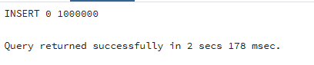
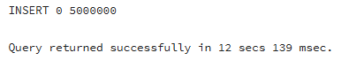
Created the same shape of table as UNLOGGED and repeated the same inserts against it:
CREATE UNLOGGED TABLE labs.test_unlogged(a int, b int);
insert into test_unlogged(a) values (generate_series(1,1000000));
insert into test_unlogged(a) values (generate_series(1,5000000));
Note: the original task text's second insert for this step is written as insert into test_simple values (generate_series(1,5000000)); — almost certainly a copy-paste typo in the task sheet, since it would just repeat the earlier test_simple insert and prove nothing about the unlogged table. Ran it against test_unlogged instead, as shown above, since that's the only version that actually compares logged vs. unlogged performance.
What to look for: both inserts against test_unlogged completing measurably faster than the equivalent-size inserts against test_simple — this is the WAL-bypass speed advantage (the docs describe roughly 10-15x for write-heavy workloads, though the exact ratio here will depend on disk/cache state).
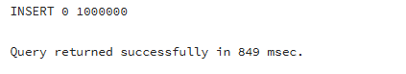
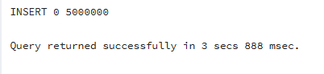
Personal takeaway: the speed difference comes entirely from skipping the write-ahead log — UNLOGGED tables trade crash-durability (they're truncated on crash recovery, and excluded from replication) for write throughput, which makes them a good fit for staging tables in an ETL pipeline where the source data can simply be reloaded if the table is lost, but a bad fit for anything that needs to survive a crash.

4. Task 2 — Understanding Inherited Tables
Created a child table that inherits from person:
CREATE TABLE labs.users(
user_id INT GENERATED BY DEFAULT AS IDENTITY PRIMARY KEY,
login VARCHAR(30)
) INHERITS (person);
What to look for: the table created with no error — users now has id, name (inherited from person) plus its own user_id and login columns.
Inserted directly into the child table:
INSERT INTO users VALUES (1, 'new Bob', 'NewLogin');
INSERT INTO users VALUES (999, 'TestUser', 'TestLogin');
What to look for: both inserts succeed — column order for a plain VALUES insert follows the table's actual column order (id, name, user_id, login), so the first value lands in id, not user_id.
Compared the three selects:
SELECT * FROM users;
SELECT * FROM person;
SELECT * FROM ONLY person;
What to look for: SELECT * FROM users returns only the 2 rows just inserted into users. SELECT * FROM person returns all rows — the 3 original person rows plus the 2 users rows (with user_id/login simply not shown, since person doesn't have those columns) — because querying a parent table implicitly includes its children's rows. SELECT * FROM ONLY person returns just the 3 original rows, since ONLY explicitly excludes child tables.
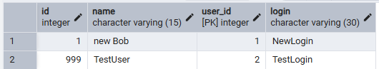
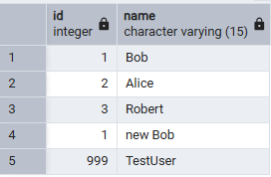
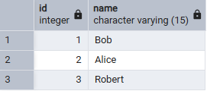
Updated through the parent, then repeated it scoped to the parent only:
UPDATE person SET name = 'not Bob' WHERE id = 1;
-- this updates every row with id = 1 across person AND its children (users), including 'new Bob'
UPDATE ONLY person SET name = 'still not Bob' WHERE id = 1;
-- ONLY restricts the UPDATE to rows physically stored in person itself
What to look for: after the first UPDATE, both the original Bob row in person and the “new Bob” row in users change to 'not Bob' — proving an UPDATE against the parent cascades into child tables by default. After the second (ONLY) UPDATE, only the row actually stored in person changes; the users row is left as 'not Bob' from the first statement, untouched by the second.
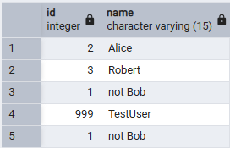
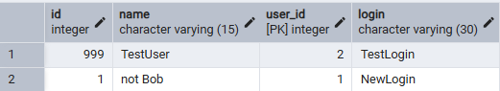

(ONLY)
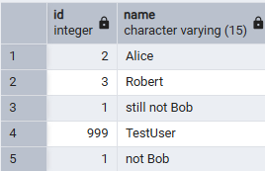
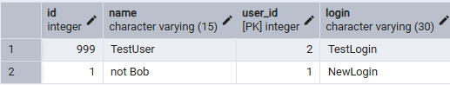
Altered the parent table's structure and constraints:
ALTER TABLE person ADD COLUMN status integer DEFAULT 0;
ALTER TABLE person ADD CONSTRAINT status CHECK (status in (0,1)) NO INHERIT;
ALTER TABLE person ADD CONSTRAINT id UNIQUE (id, name);
What to look for: the new status column appears on BOTH person and users (columns are always inherited), but \d on each table shows the CHECK constraint only listed under person, not users — that's exactly what NO INHERIT does: propagate the column, but not this particular constraint. The UNIQUE (id, name) constraint, on the other hand, is a table constraint tied to an index; PostgreSQL never lets unique/primary-key constraints propagate to children at all, with or without NO INHERIT, so it also shows up only on person.

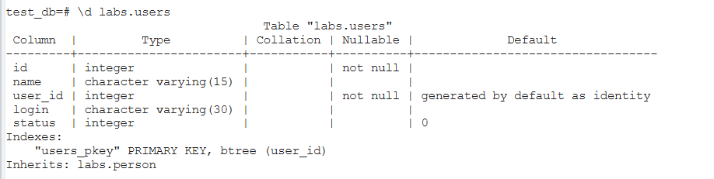
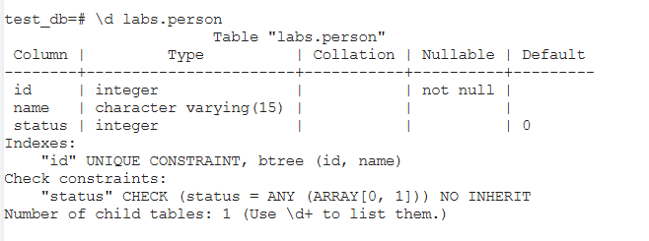

5. Task 3 — BRIN vs B-Tree
Created a wide table and filled it with ~5 years of synthetic timestamped data (10-second intervals, roughly 15.8 million rows):
CREATE TABLE labs.test_index (
num float NOT NULL,
load_date timestamptz NOT NULL
);
INSERT INTO test_index(num, load_date)
SELECT random(), x
FROM generate_series('2017-01-01 0:00'::timestamptz,
'2021-12-31 23:59:59'::timestamptz, '10 seconds'::interval) x;
SELECT pg_size_pretty(pg_relation_size('test_index'));
What to look for: the insert taking a noticeable amount of time (millions of rows generated on the fly), and pg_relation_size reporting a size in the hundreds of MB to low GB range — this is the “no index yet” baseline table size to compare against the index sizes below.
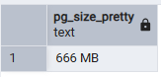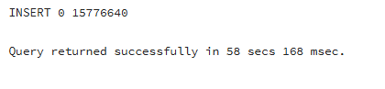

Ran the baseline query with no index, timing it:

EXPLAIN ANALYZE
SELECT date_trunc('year', load_date), max(num)
FROM test_index
WHERE load_date BETWEEN '2021-09-01 0:00' AND '2021-10-31 11:59:59'
GROUP BY 1
ORDER BY 1;
What to look for: the plan showing a Seq Scan over the whole table (with a Filter on load_date), and an "Execution Time" line at the bottom — this is the number to beat once an index is added.

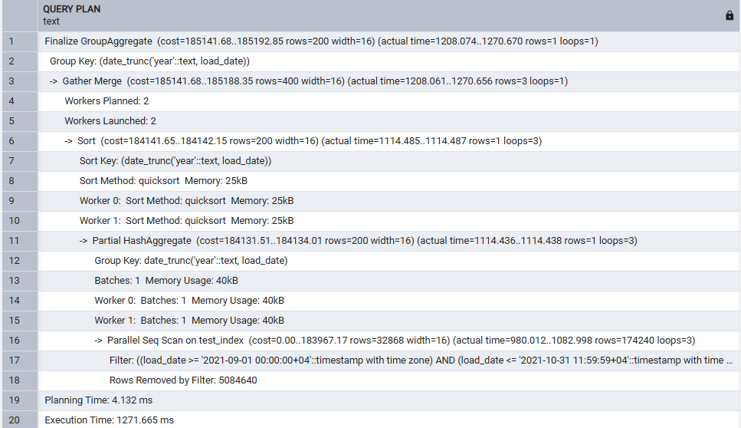

B-Tree index
CREATE INDEX idx_test_index_btree ON test_index(load_date);
-- note how long CREATE INDEX itself takes
EXPLAIN ANALYZE
SELECT date_trunc('year', load_date), max(num)
FROM test_index
WHERE load_date BETWEEN '2021-09-01 0:00' AND '2021-10-31 11:59:59'
GROUP BY 1
ORDER BY 1;
SELECT pg_size_pretty(pg_relation_size('idx_test_index_btree'));
DROP INDEX idx_test_index_btree;
What to look for: CREATE INDEX taking noticeably longer than a BRIN build would (it has to sort/insert an entry for every one of the ~15.8M rows); the plan now switching to an Index Scan (or Bitmap Index Scan) on idx_test_index_btree with a much lower Execution Time than the seq-scan baseline; and the index's own size — typically a few hundred MB, i.e. a large fraction of the table's own size, since B-tree stores one entry per row.

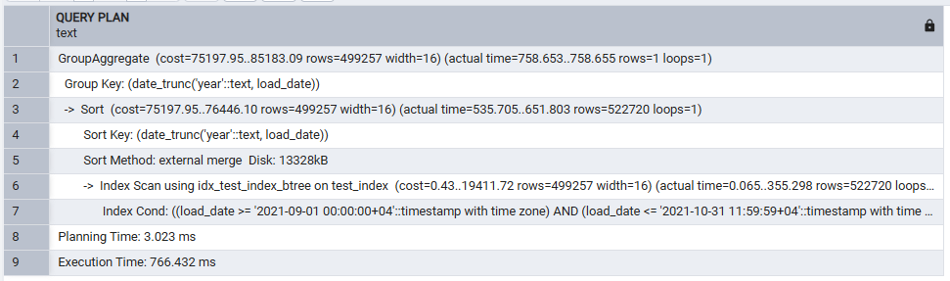
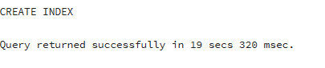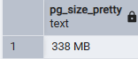

BRIN index
CREATE INDEX idx_test_index_brin ON test_index USING brin(load_date);
-- note how long CREATE INDEX itself takes
EXPLAIN ANALYZE
SELECT date_trunc('year', load_date), max(num)
FROM test_index
WHERE load_date BETWEEN '2021-09-01 0:00' AND '2021-10-31 11:59:59'
GROUP BY 1
ORDER BY 1;
SELECT pg_size_pretty(pg_relation_size('idx_test_index_brin'));
DROP INDEX idx_test_index_brin;
DROP TABLE test_index;
What to look for: CREATE INDEX finishing much faster than the B-Tree build (BRIN only stores a min/max summary per page range, not a per-row entry); the plan switching to a Bitmap Heap Scan driven by a Bitmap Index Scan on idx_test_index_brin, with an Execution Time that should land somewhere between the seq-scan baseline and the B-Tree result — BRIN is only this effective because load_date happens to be naturally correlated with physical insertion order (the data was inserted in date order); and the index size should be dramatically smaller than the B-Tree index, typically just tens or hundreds of KB, since it stores one summary entry per page range rather than one entry per row.
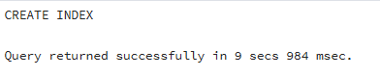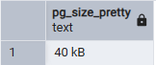
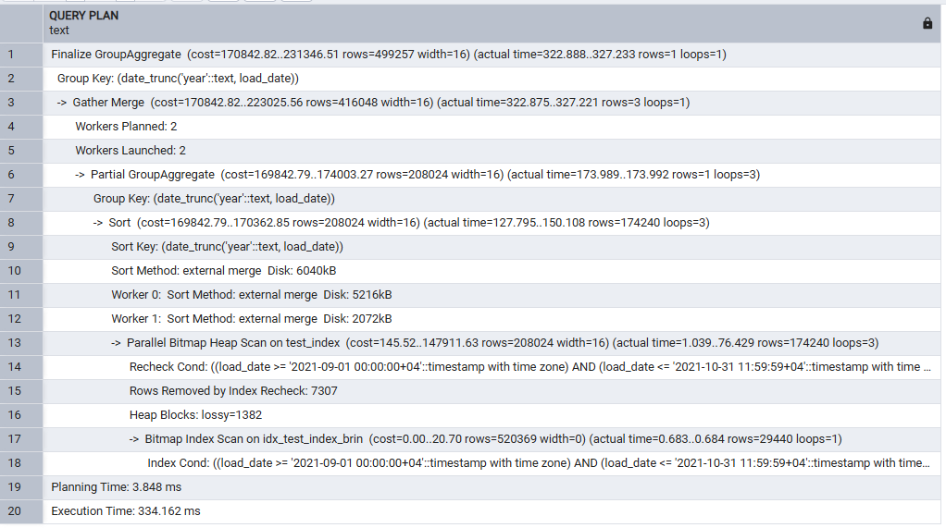

Personal takeaway: for this naturally date-ordered dataset, BRIN gives most of the B-Tree's query speedup at a small fraction of both the build time and the on-disk size — but that only holds because load_date correlates with physical row order; a BRIN index on a randomly-ordered column would be far less useful.

6. Task 4 — GIN vs GiST
Created a 10-million-row table of MD5 hashes and checked its size:
CREATE TABLE labs.test_index AS
SELECT id, md5(id::text) AS t_hash
FROM generate_series(1, 10000000) AS id;
SELECT pg_size_pretty(pg_relation_size('test_index'));
What to look for: table creation taking a while (10M rows, each with an MD5 computed on the fly), and pg_relation_size reporting roughly half a GB to 1GB — this is the baseline table size, since CREATE TABLE AS SELECT does not create any indexes.
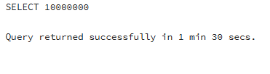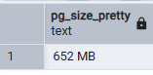

Ran the baseline substring search with no index:
EXPLAIN ANALYZE SELECT * FROM test_index WHERE t_hash LIKE '%ceea167a5a%';
What to look for: a Seq Scan over all 10M rows, with an Execution Time in the low seconds — a leading-wildcard LIKE pattern like this can never use a plain B-Tree index, which is exactly the problem GiST/GIN + pg_trgm solve below.

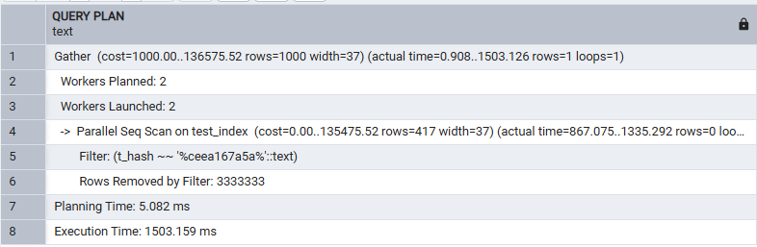

GiST index (trigram)
CREATE EXTENSION pg_trgm;
CREATE INDEX idx_text_index_gist ON test_index USING gist(t_hash gist_trgm_ops);
-- note how long CREATE INDEX itself takes
SELECT pg_size_pretty(pg_relation_size('test_index'));
EXPLAIN ANALYZE SELECT * FROM test_index WHERE t_hash LIKE '%ceea167a5a%';
SELECT pg_size_pretty(pg_relation_size('idx_text_index_gist'));
DROP INDEX idx_text_index_gist;
Note: the task sheet's step 3 says “Repeat step 1” to check the table size again — the table itself is unchanged by adding an index, so this is really re-checking pg_relation_size('idx_text_index_gist') (the index, not the table) for comparison against the GIN index size below; included both queries above.
What to look for: pg_trgm breaking t_hash into overlapping 3-character trigrams so the LIKE pattern can be matched via the index; the plan switching to a Bitmap Heap Scan / Index Scan on idx_text_index_gist with an Execution Time well under the seq-scan baseline; CREATE INDEX itself taking some time to build the tree; and an index size noticeably larger than the base table (trigram indexes store many overlapping keys per row).

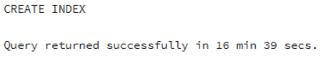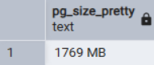
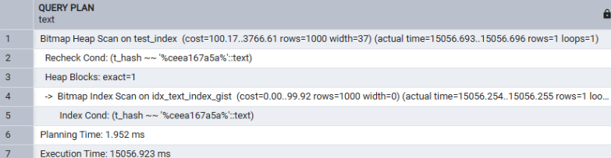

GIN index (trigram)
CREATE INDEX idx_text_index_gin ON test_index USING gin(t_hash gin_trgm_ops);
-- note how long CREATE INDEX itself takes
EXPLAIN ANALYZE SELECT * FROM test_index WHERE t_hash LIKE '%ceea167a5a%';
SELECT pg_size_pretty(pg_relation_size('idx_text_index_gin'));
DROP INDEX idx_text_index_gin;
DROP TABLE test_index;
What to look for: CREATE INDEX taking noticeably longer to build than the GiST version (GIN maintains a full posting list per trigram key, which is more expensive to construct and to update); the query plan again using the index with an Execution Time in the same ballpark as (often a little faster than) the GiST result, since GIN lookups are typically quicker once built; and an index size that is usually the largest of the three structures compared (base table / GiST / GIN) for this kind of data.
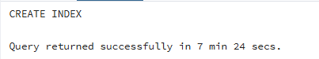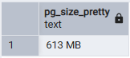
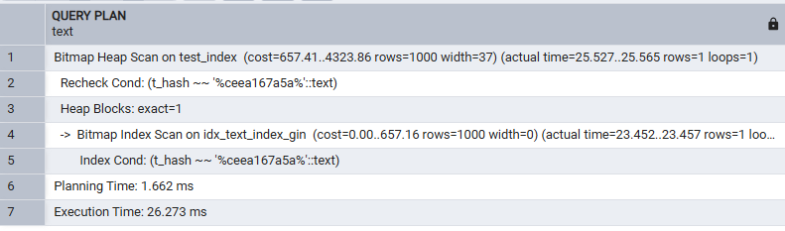

Personal takeaway: GIN wins on lookup speed and GiST wins on build/update speed and index size — the general trigram-search rule of thumb (GIN for read-heavy, GiST for write-heavy) held up on this data.

7. Task 5 — CSV File as a Table
Installed file_fdw and created the server object every foreign table needs:
CREATE EXTENSION file_fdw;
CREATE SERVER test_import FOREIGN DATA WRAPPER file_fdw;
What to look for: both statements complete successfully — CREATE EXTENSION file_fdw needs the current role to have appropriate privileges (superuser, or a role granted the extension), which the default local postgres/owner role has.
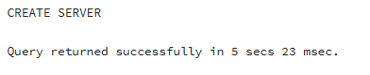

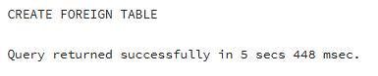
Saved cities_list.csv somewhere on the same machine the PostgreSQL server process runs on (not just where pgAdmin runs — for a local install these are the same machine), then created the foreign table pointing at it:
CREATE FOREIGN TABLE labs.test_foreign_table
(
LatD INT,
LatM INT,
LatS INT,
NS TEXT,
LonD INT,
LonM INT,
LonS INT,
EW TEXT,
City TEXT,
State TEXT
)
SERVER test_import
OPTIONS
(
filename 'C:/temp/cities_list.csv',
format 'csv',
header 'true',
delimiter ','
);
Note: replace C:/temp/cities_list.csv with the actual path where the file was saved. The path is read by the PostgreSQL server process itself, not by pgAdmin, so it must exist on the machine PostgreSQL is running on, and the account the PostgreSQL service runs as needs read permission on it — a common failure here is “ERROR: could not open file ... Permission denied”, fixed by moving the file out of a user-profile-restricted folder (e.g. into a plain C:/temp/ style path) or adjusting permissions.

What to look for: CREATE FOREIGN TABLE succeeding with no error once the path/permissions are correct.
Queried the foreign table directly:
SELECT * FROM test_foreign_table;
SELECT count(*) FROM test_foreign_table;
What to look for: all rows from cities_list.csv returned as ordinary query results, and count(*) matching the number of data rows in the file (total lines minus the header row) — every query against a file_fdw table re-reads the file from disk, so this always reflects the file's current contents.

Whole table rows:

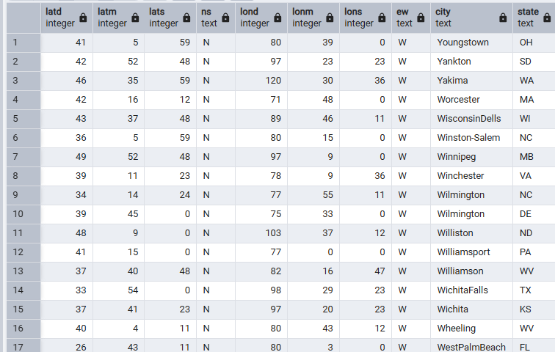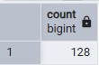
Created a materialized view over the foreign table and queried it:
CREATE MATERIALIZED VIEW labs.mview AS SELECT * FROM test_foreign_table;
SELECT count(*) FROM mview;
What to look for: the materialized view's count matching the foreign table's count at creation time — it copied the current result set to disk rather than just storing the query.
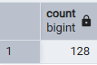
Deleted a few data rows directly from cities_list.csv using a text editor (outside PostgreSQL entirely — this is editing the file, not running SQL), saved the file, then re-ran both counts:
SELECT count(*) FROM test_foreign_table; -- re-reads the file live
SELECT count(*) FROM mview; -- still shows the OLD, cached count
What to look for: count(*) FROM test_foreign_table immediately reflects the smaller row count, since file_fdw reads the file fresh every time — but count(*) FROM mview is unchanged, still showing the original (now stale) number, because a materialized view's data is a point-in-time snapshot that does not update itself when the underlying source changes.
Result: count(*) FROM test_foreign_table drops immediately to the new, smaller row count, since file_fdw re-reads cities_list.csv from disk on every query — there is no caching at that layer. count(*) FROM mview, on the other hand, stays exactly at its original value (128), because a materialized view only stores a snapshot of the query's result at the moment it was created (or last refreshed); editing the source file underneath it has no effect on data already materialized to disk. Side by side, this is the clearest possible demonstration of the trade-off described in the theory recap: the foreign table is always live but pays a full file read on every query, while the materialized view is cheap to read but silently goes stale the moment the underlying source changes.
Refreshed the materialized view to bring it back in sync:
REFRESH MATERIALIZED VIEW mview;
SELECT count(*) FROM mview;
What to look for: REFRESH MATERIALIZED VIEW re-runs the underlying query and replaces the view's stored data wholesale; count(*) FROM mview now matches count(*) FROM test_foreign_table again. Note this is a blocking operation (the view is unreadable mid-refresh) unless run as REFRESH MATERIALIZED VIEW CONCURRENTLY, which additionally requires a unique index on the view.
Result: REFRESH MATERIALIZED VIEW mview re-runs SELECT * FROM test_foreign_table underneath and wholesale replaces the view's stored rows with the current result — it does not patch the difference, it recomputes from scratch. After the refresh, count(*) FROM mview matches count(*) FROM test_foreign_table again, both showing the reduced row count from the edited CSV file. This is also a blocking operation: any session trying to SELECT from mview while the REFRESH is running would wait until it completes, since a plain REFRESH (without CONCURRENTLY) takes an exclusive lock on the view for the duration of the rebuild.

8. Summary
UNLOGGED tables trade crash-durability for write speed by skipping WAL — a good fit for disposable/staging data in an ETL flow. Inherited tables let a child table add columns on top of a parent's, with the parent's queries auto-including child rows (unless ONLY is used) and most constraint types (except uniqueness/PK) inherited by default, or explicitly excluded with NO INHERIT. For indexing, the right structure depends on the data shape and access pattern: B-Tree is the safe general-purpose default; BRIN trades lookup speed for a tiny footprint and fast builds, but only works well when the column is physically correlated with row order; and for substring/fuzzy text search neither B-Tree nor Hash can help at all — GiST and GIN (via pg_trgm) make that possible, with GiST favoring faster builds/updates and GIN favoring faster lookups. Finally, file_fdw exposes a flat file as a live, read-through foreign table, and layering a materialized view on top of it trades that live-ness for caching — cheap repeated reads, at the cost of needing an explicit REFRESH to stay current.

